Advance Soft Logics — AI/ML Internship
Week 4 Report: Model Evaluation, Hyperparameter Tuning & Ensemble Methods
Hashir Ahmed

What I Built
I extended the Week 3 Titanic survival-classification project with a proper model-selection workflow: 5-fold stratified cross-validation for the baseline models, a GridSearchCV hyperparameter search over Random Forest, a RandomizedSearchCV search over Gradient Boosting, and a final results table comparing every model — including the Week 3 baseline — on the same held-out test set. All preprocessing (imputation, scaling, one-hot encoding) stays inside a single scikit-learn Pipeline, so every cross-validation fold and every search candidate refits preprocessing on training data only, with no leakage from validation or test data.
The final model was selected using cross-validated F1 only, before the test set was touched — Gradient Boosting (mean CV F1 = 0.769) was chosen over the tuned Random Forest (0.763). The chosen pipeline was then evaluated once on the untouched test set (accuracy 0.816, F1 0.740), saved with joblib, and its hyperparameters, test metrics, and feature/permutation importances were written to a JSON record for reproducibility.

Results
Model | CV F1 (mean±std) | Test Acc. | Test Prec. | Test Recall | Test F1
LogReg (Week 3 baseline, single split) | — | — | — | — | 0.761
LogReg (Week 4, 5-fold CV) | 0.739 ± 0.019 | 0.793 | 0.722 | 0.754 | 0.738
Random Forest (untuned, 5-fold CV) | 0.757 ± 0.025 | 0.805 | 0.774 | 0.696 | 0.733
Random Forest (GridSearchCV-tuned) | 0.763 | 0.793 | 0.750 | 0.696 | 0.722
Gradient Boosting (RandomizedSearchCV-tuned) — FINAL | 0.769 | 0.816 | 0.810 | 0.681 | 0.740

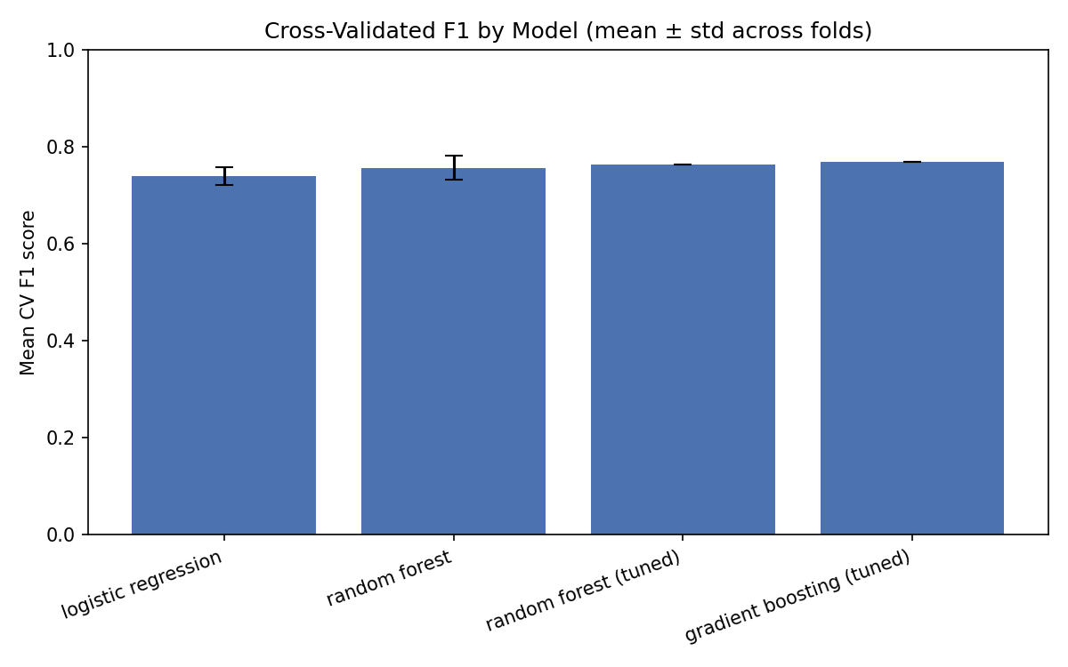
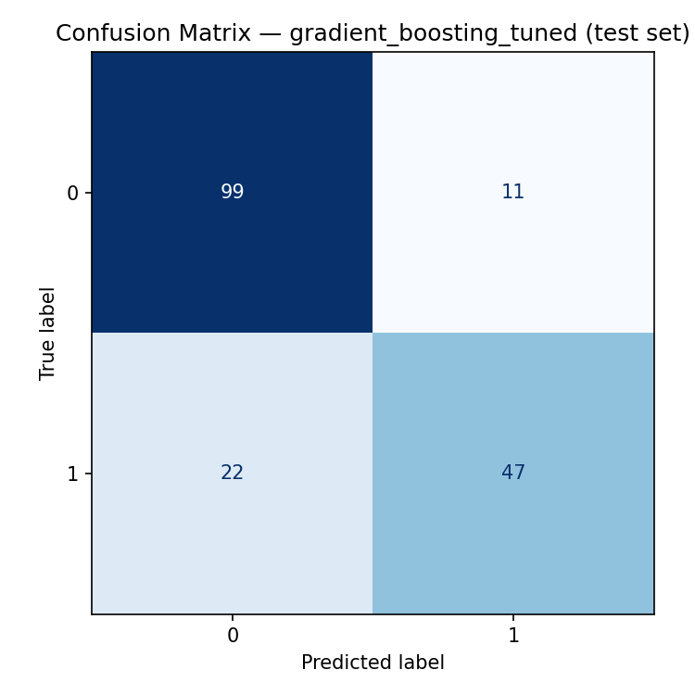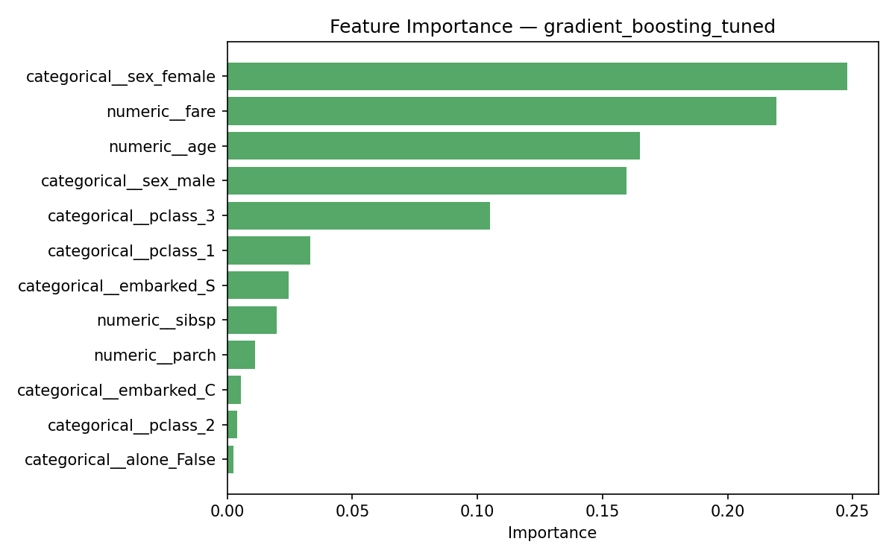

Challenges Faced & How I Solved Them
- Mixed-dtype categorical columns (int, bool, str) broke the ColumnTransformer's categorical imputer with a 'could not convert string to float' error. Solved by explicitly casting all categorical feature columns to string dtype before the Pipeline sees them, so pandas no longer hands the transformer a block it silently coerces to a single numeric dtype.
- GradientBoostingClassifier has no class_weight parameter, unlike Logistic Regression and Random Forest. Since the imbalance (62/38) is only moderate, I relied on precision/recall/F1 rather than accuracy alone for Gradient Boosting instead of adding manual sample-weighting complexity, and documented that decision rather than silently ignoring it.
- RandomizedSearchCV needed a genuine distribution, not a fixed list, to sample efficiently across a wide parameter space — used scipy.stats.randint/uniform instead of a coarse grid, which let 40 sampled configurations cover a much larger space than an equivalent GridSearchCV run would in reasonable time.
- Avoiding test-set peeking during model selection required discipline: all model comparison during tuning used cross_val_score / GridSearchCV/RandomizedSearchCV's internal CV, and the test set was only evaluated once, after the final model was already chosen.

Conclusion
This week extended the Week 3 Titanic survival classifier with stratified 5-fold cross-validation, systematic hyperparameter search, and two ensemble models. Cross-validating the Week 3-style Logistic Regression baseline and an untuned Random Forest first confirmed that a single train/test split understates real variability: Logistic Regression scored 0.739 ± 0.019 mean F1 across folds, and Random Forest 0.757 ± 0.025 — a noticeably wider spread than a single split would ever reveal.
GridSearchCV over Random Forest (n_estimators, max_depth, min_samples_split, min_samples_leaf) raised its cross-validated F1 to 0.763, and RandomizedSearchCV over Gradient Boosting (40 sampled configurations across learning_rate, max_depth, subsample, and min_samples_leaf) reached 0.769 — the best cross-validated score of any model tried. Because model selection was made on validation evidence rather than the test set, Gradient Boosting was chosen as the final model before it was ever evaluated on held-out data. On the untouched test set it reached accuracy 0.816, precision 0.810, recall 0.681, and F1 0.740 — slightly below the Week 3 baseline's single-split F1 of 0.761, which is a reasonable outcome: Week 3's number came from one lucky-or-unlucky split, while this week's figure reflects the model most consistently strong across five different splits, at some cost to this particular test partition.
Sex, fare, age, and passenger class dominated feature importance for the final model, corroborated by permutation importance on the test set, consistent with the historical "women and children first, and first-class passengers had better odds" account of the disaster. Class imbalance was mild (62% did not survive vs. 38% who did), so `class_weight="balanced"` was applied to Logistic Regression and Random Forest; Gradient Boosting has no native class_weight parameter, and given the imbalance was modest, metrics beyond accuracy (precision, recall, F1) were relied on instead of adding sample-weighting complexity.
Next steps: try XGBoost/LightGBM for a stronger boosting baseline, run nested cross-validation for a less optimistic performance estimate, and engineer a family-size feature from sibsp/parch.

